**BookSwap Hub**

Saurabh Kale

IFT 458/554: Middleware Programming & Database Security

Dinesh Sthapit

December 1st, 2023

**Table of Contents**

Abstract 3

Introduction 3

Problem Statement 4

Scope and Limitations 4

Justification of Technology Stack for Bookswap Hub 4

Project Design 5

Screenshots 10

Testing 21

Implementation 25

Learning Outcomes 27

Constructive Feedback 27

References 28

Abstract

BookSwap Hub is an innovative online platform designed to facilitate the exchange and sharing of books among avid readers. The platform serves as a dynamic hub where users can add, discover, and exchange books with fellow enthusiasts. With a user-friendly interface, members can easily list their books for borrowing or trading, fostering a vibrant community centered around a shared love for literature. BookSwap Hub not only provides a seamless experience for adding and managing books but also incorporates features for requesting and accepting exchanges, enhancing the overall reading experience. Join our literary exchange network and unlock a world of diverse stories, connecting readers and fostering a sense of community through the joy of sharing books.

Introduction

Bookswap Hub is a web application designed to facilitate book exchanges among users, allowing them to add, browse, and request books for borrowing or trading. The project employs a Node.js backend with Express for routing and MongoDB as the database, while the frontend is rendered using EJS templates. User authentication is implemented using JWT tokens, and the system includes features such as user registration, login, book addition, and request processing. The application incorporates various middleware functions for authentication and authorization, ensuring secure access to specific routes. The codebase follows the Model-View-Controller (MVC) architecture, with separate controllers handling user authentication, book-related operations, and middleware managing authentication and authorization. The project includes routes for adding, updating, and deleting books, as well as handling book requests and user authentication. Additionally, there are features for accepting book requests and an about page providing information about the student creator. Overall, Bookswap Hub is a comprehensive book exchange platform with a focus on user-friendly interactions and secure functionalities.

Problem Statement

Bookswap Hub aims to address the need for a user-friendly and secure platform for book enthusiasts to exchange their books through borrowing or trading. The existing problem lies in the lack of a dedicated application that seamlessly connects users with similar literary interests, making the process of book exchange cumbersome and less efficient. Bookswap Hub seeks to streamline this experience by providing a centralized hub where users can easily add, browse, and request books, enhancing the overall accessibility and convenience of book exchanges while ensuring the security of user data and transactions.

Scope and Limitations

The scope of Bookswap Hub encompasses creating an intuitive and efficient platform for users to facilitate book exchanges, fostering a community of avid readers. Users can seamlessly add, explore, and request books for borrowing or trading, enhancing the overall accessibility of diverse literary collections. The platform's scope extends to user authentication, authorization, and transactional security to safeguard sensitive information. However, certain limitations may include the platform's reliance on user-generated content for book listings, potentially leading to variations in data quality. Additionally, real-time communication features for users to discuss exchange details are not implemented, and the platform does not currently support international book exchanges. Continuous improvement and user feedback will be integral to addressing these limitations and refining the Bookswap Hub experience.

Justification of Technology Stack for Bookswap Hub

1. **Node.js:**
   * Non-blocking, event-driven architecture ensures efficient handling of concurrent connections.
   * Suitable for real-time applications, enhancing responsiveness.
2. **Express.js:**
   * Lightweight and flexible framework simplifies server-side development.
   * Streamlines routing, middleware integration, and overall application structure.
3. **MongoDB:**
   * NoSQL database accommodates the dynamic and schema-less nature of book-related data.
   * Provides scalability and seamless integration with Node.js.
4. **JWT (JSON Web Tokens):**
   * Enhances security by securely transmitting user information between client and server.
   * Supports stateless authentication, improving scalability and performance.
5. **EJS Templates:**
   * Embedded JavaScript templates facilitate dynamic HTML rendering on the client side.
   * Integrates seamlessly with Express.js for efficient server-side rendering.
6. **Bootstrap:**
   * Ensures a responsive and visually appealing user interface.
   * Accelerates front-end development with pre-designed UI components.

Project Design

**Architecture and Design**

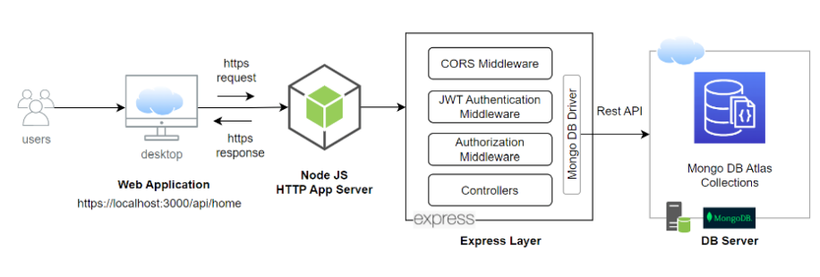

**Sequence Diagram-**

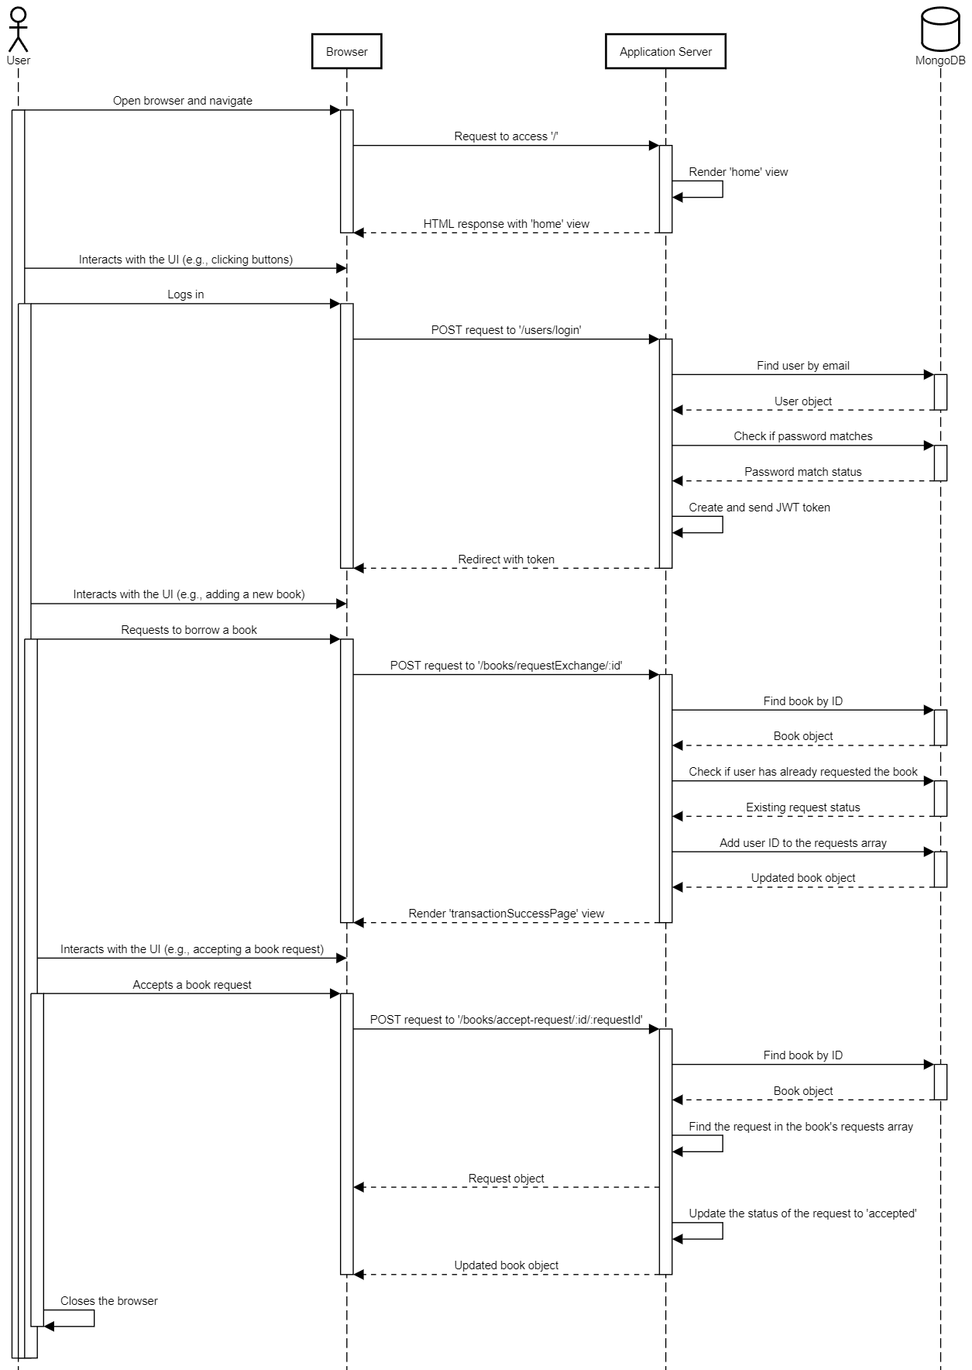

**Flowchart**

**-**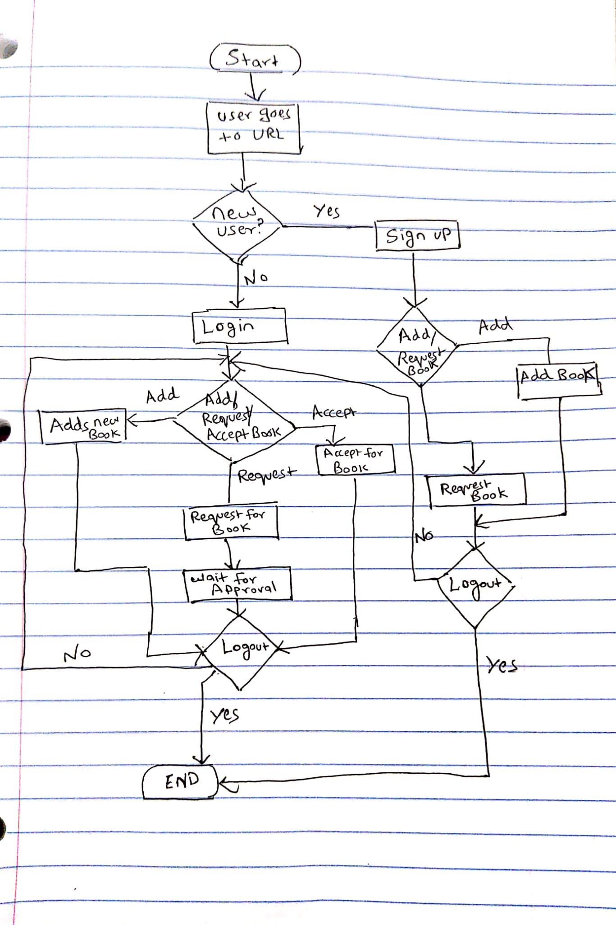

**Pseudocode-**

// User Actions

// Login

function userLogin(email, password):

if email and password are present:

send login request to server

if login successful:

store user token locally

redirect to user dashboard

else:

display login error message

else:

display error, missing credentials

// Add a Book

function addBook(title, author, description, exchangeType):

if user is authenticated:

send add book request to server

if book added successfully:

redirect to user's book list

else:

display error, book not added

else:

redirect to login

// Request a Book

function requestBook(bookId):

if user is authenticated:

send book request to server

if request successful:

display success message

else:

display error, request failed

else:

redirect to login

// Accept Book Request

function acceptBookRequest(bookId, requestId):

if user is authenticated and is the owner of the book:

send accept request to server

if acceptance successful:

display success message

else:

display error, acceptance failed

else:

redirect to login

// Logout

function userLogout():

clear locally stored user token

redirect to home page

// Usage Examples

userLogin("test@gmail.com", "test12345")

addBook("Wings of Fire", "APJ Kalam", "Autobiography", "trade")

requestBook("12345") // Assuming '12345' is the book ID

acceptBookRequest("67890", "54321") // Assuming '67890' is the book ID and '54321' is the request ID

userLogout()

**API Specifications-**

**Authentication:**

|  |  |  |  |
| --- | --- | --- | --- |
| **Action** | **Endpoint** | **Method** | **Payload** |
| Signup | /users/signup | POST | name,email, password, passwordConfirmation |
| Login | /users/login | POST | Email, Password |
| Logout | /users/logout | GET | - |
| About | /users/about | GET | - |

**Books:**

|  |  |  |  |
| --- | --- | --- | --- |
| Action | Endpoint | Method | Payload |
| Add Book | /book/createBook | POST | Title,author,description, exchangeType |
| Get Books | /books/getBooks | GET | - |
| Request Book | /books/requestExchange/:id | POST | Id (Book Id) |
| Accept Request | /books/accept-request/:id/:requestId | POST | Id (book Id), request Id |

Screenshots

**Database-**

Created New Database

Bookexchanges-

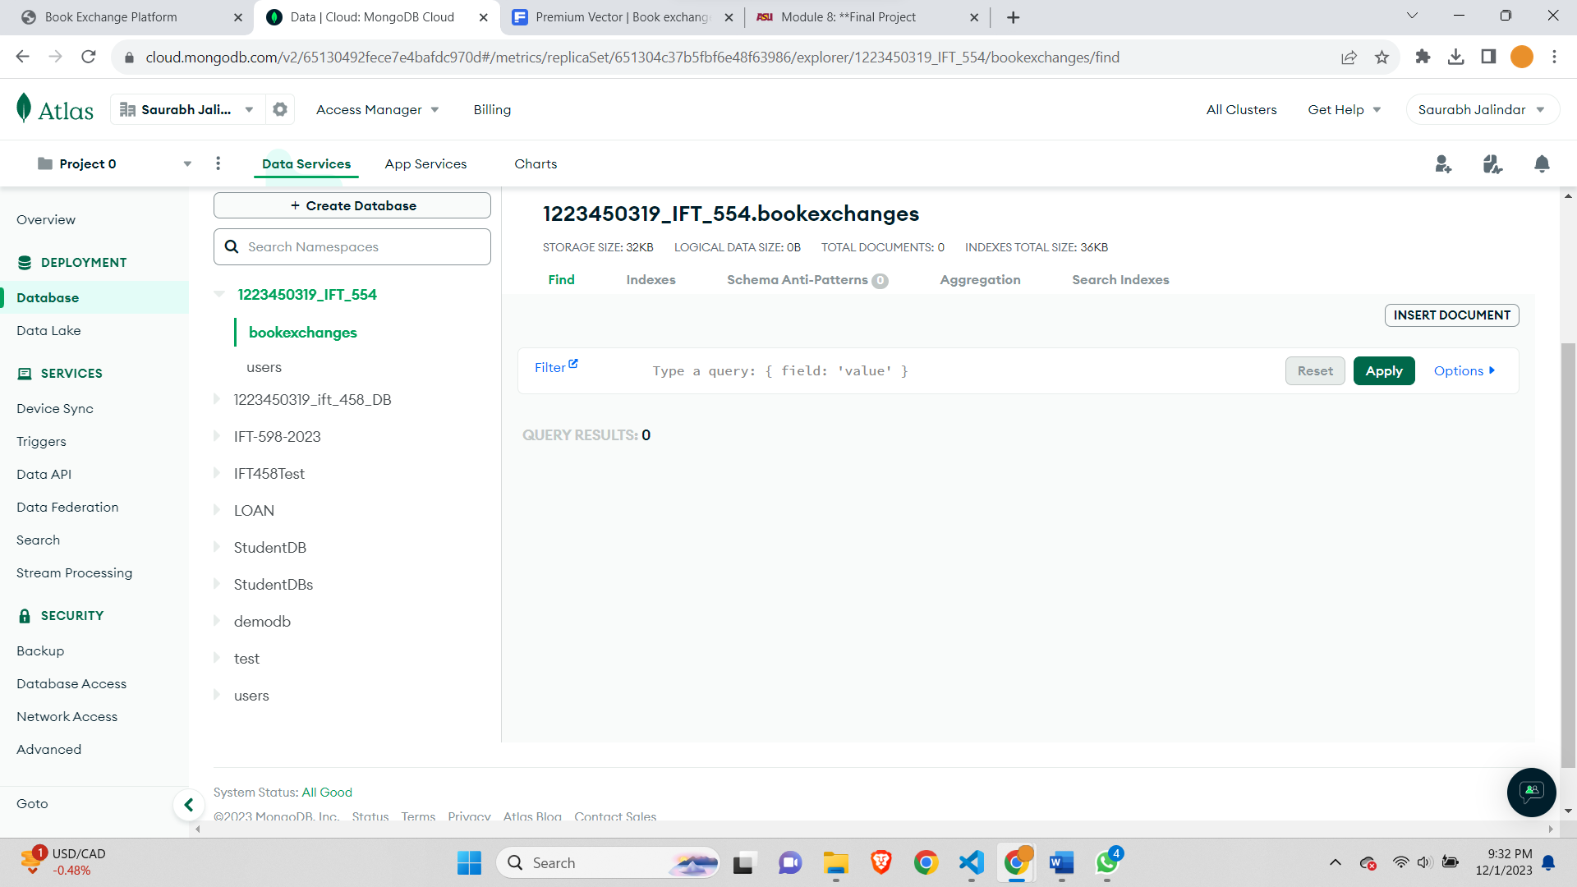

User-

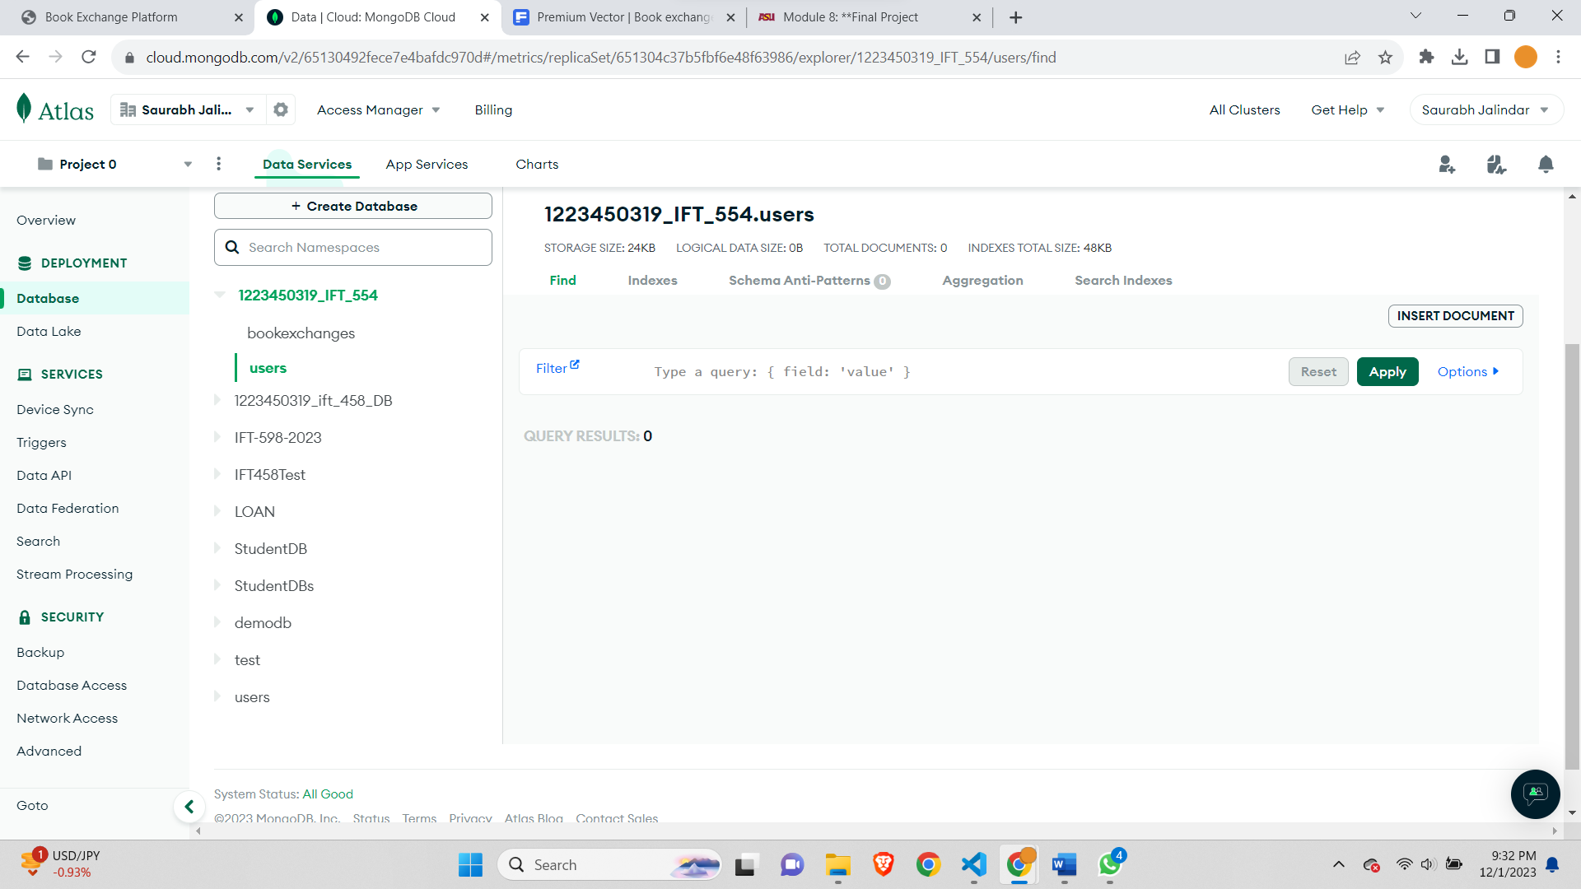

Home page-

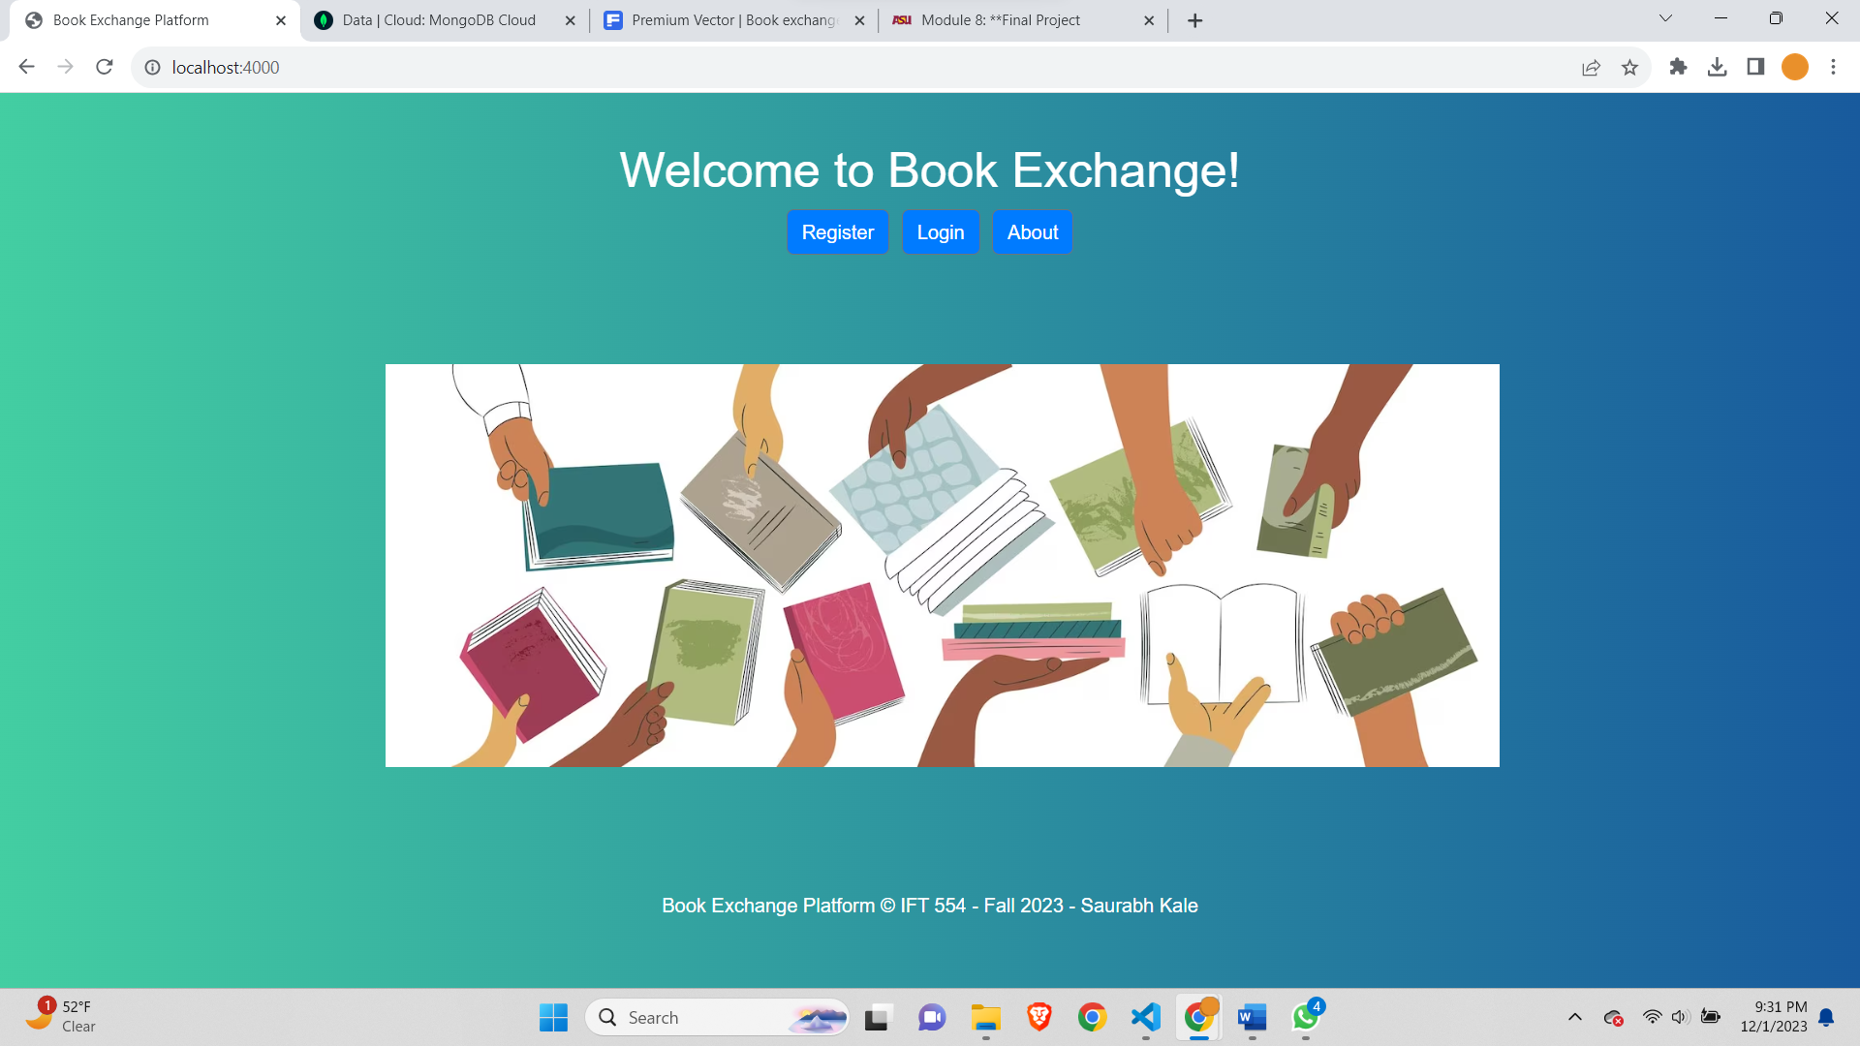

Signup Page-

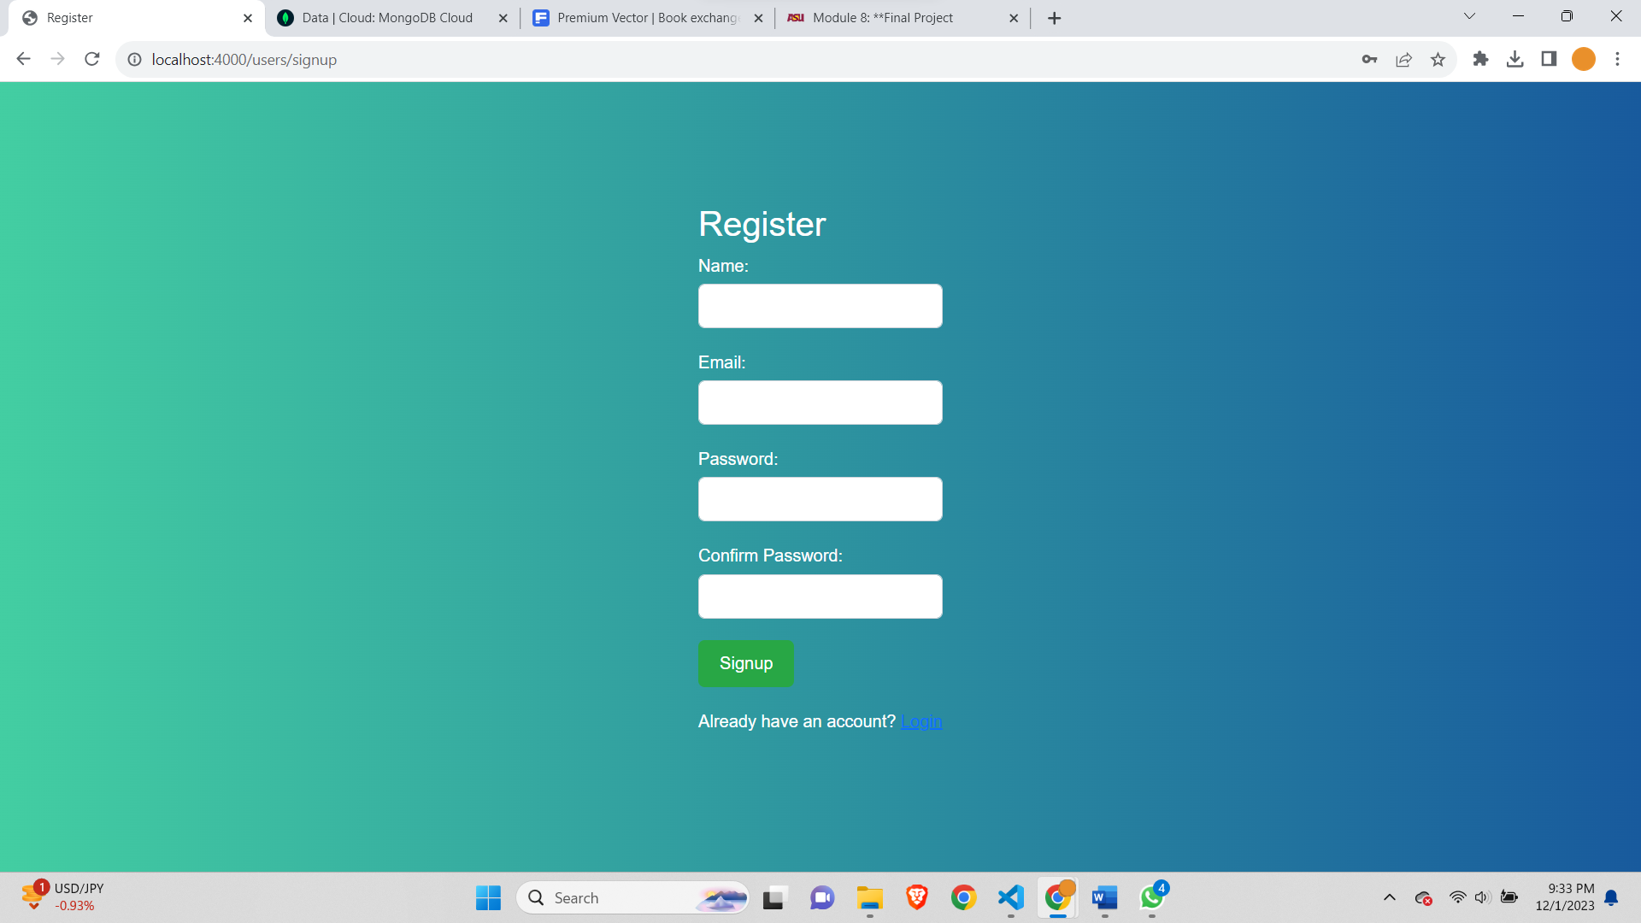

After sign Up First Page (My Books List)-

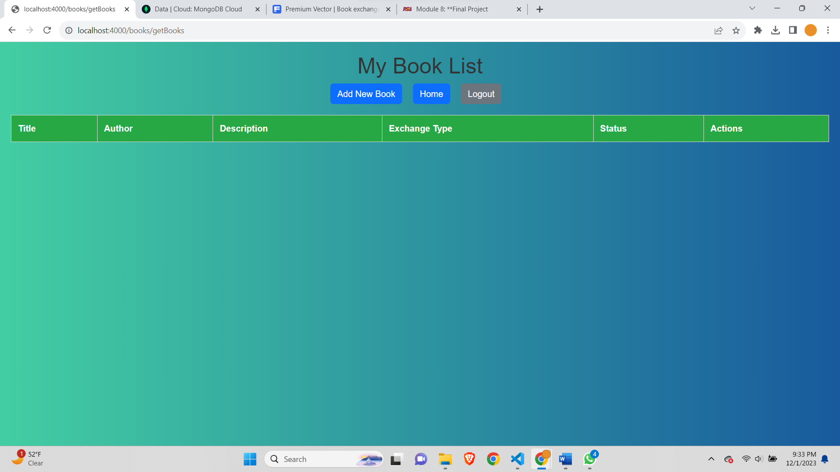

Add book -

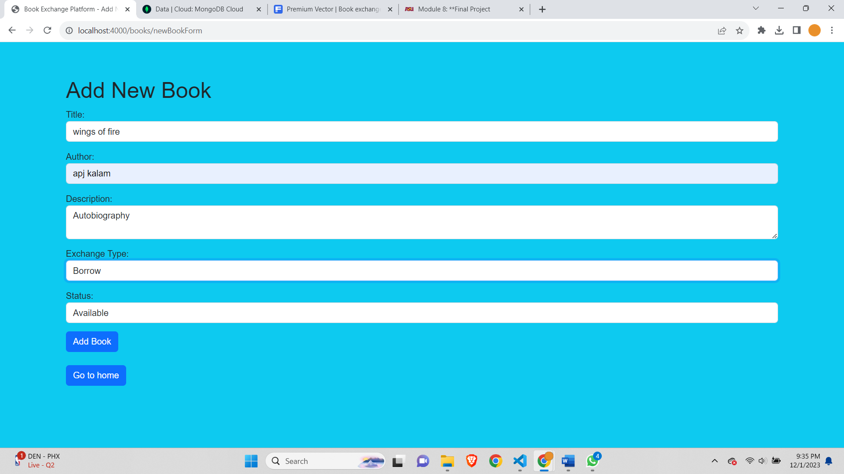

There are two options on add new Book incase the user just wishes to go back can click on go to home button.

After Adding Book-

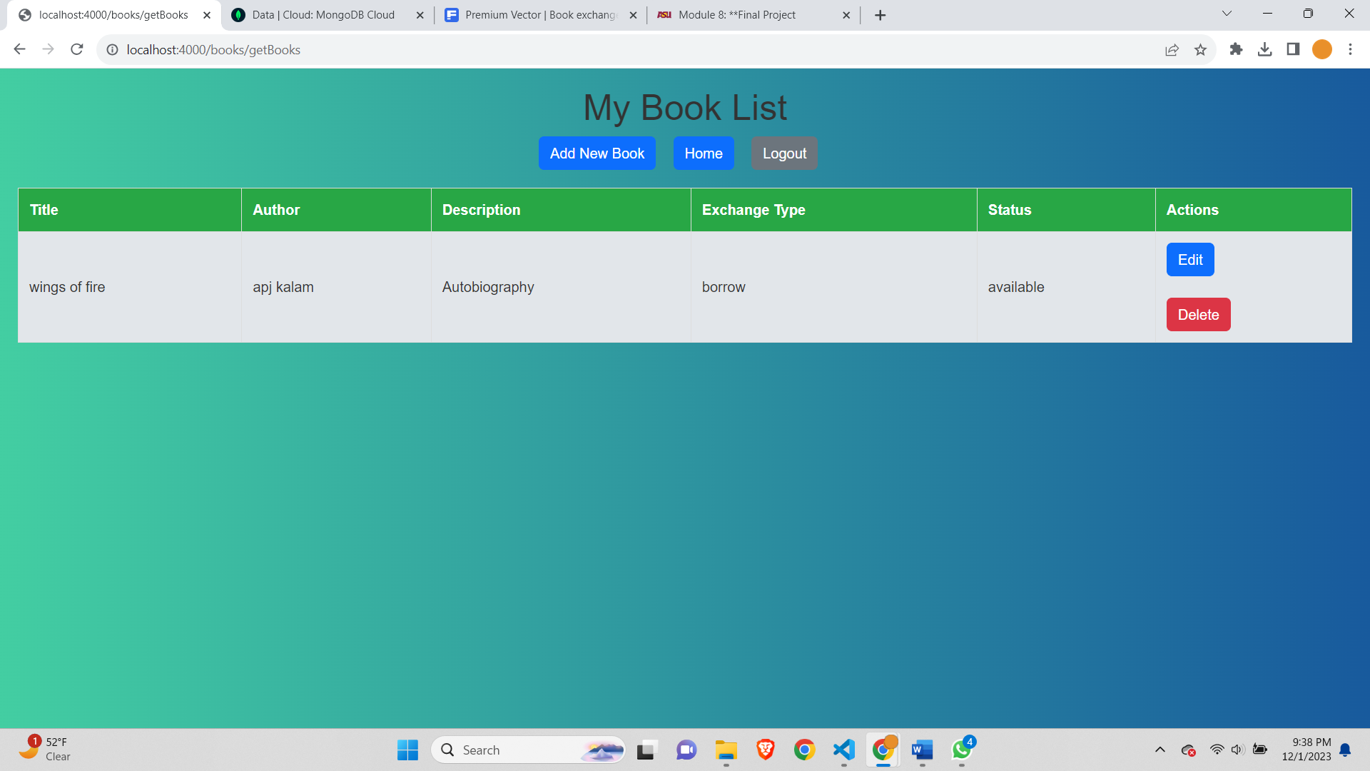

In My books page we can have the option of editing and deleting the book.

Edit book-

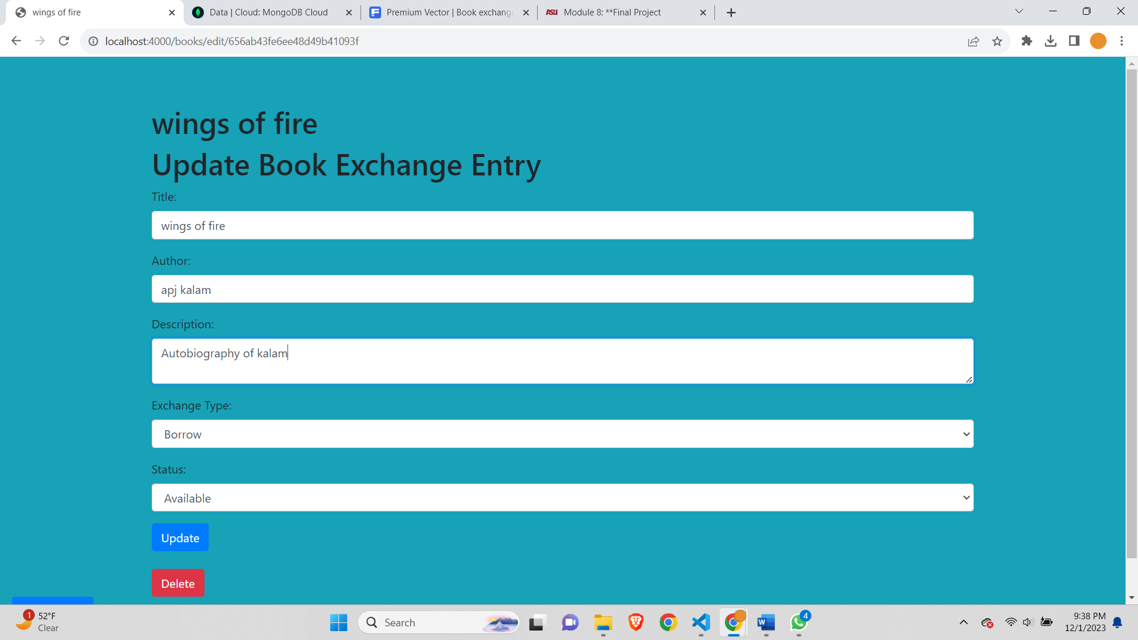

After editing the book-

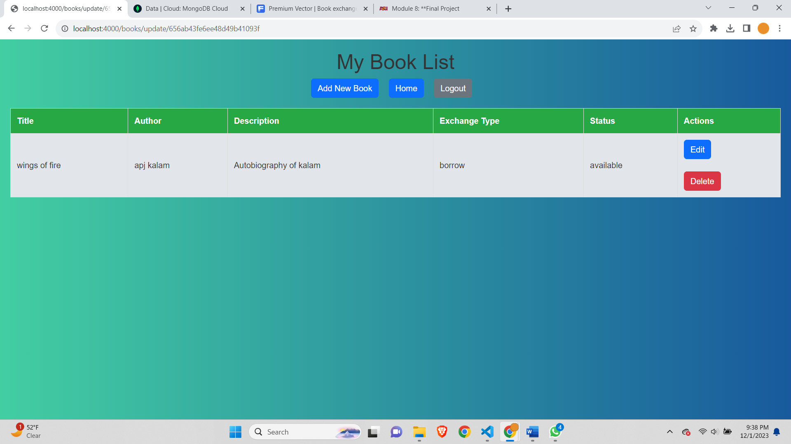

After adding one more book-

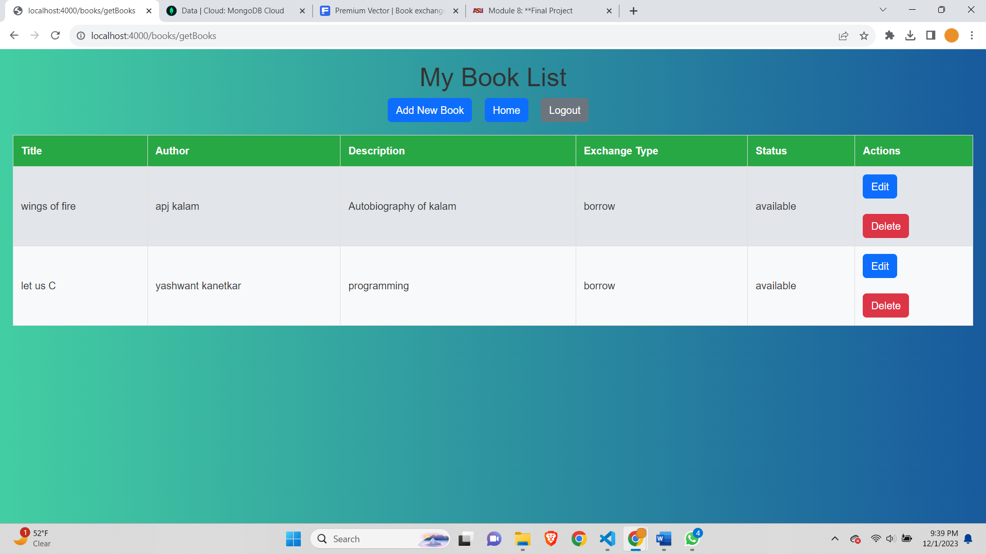

After deleting one book-

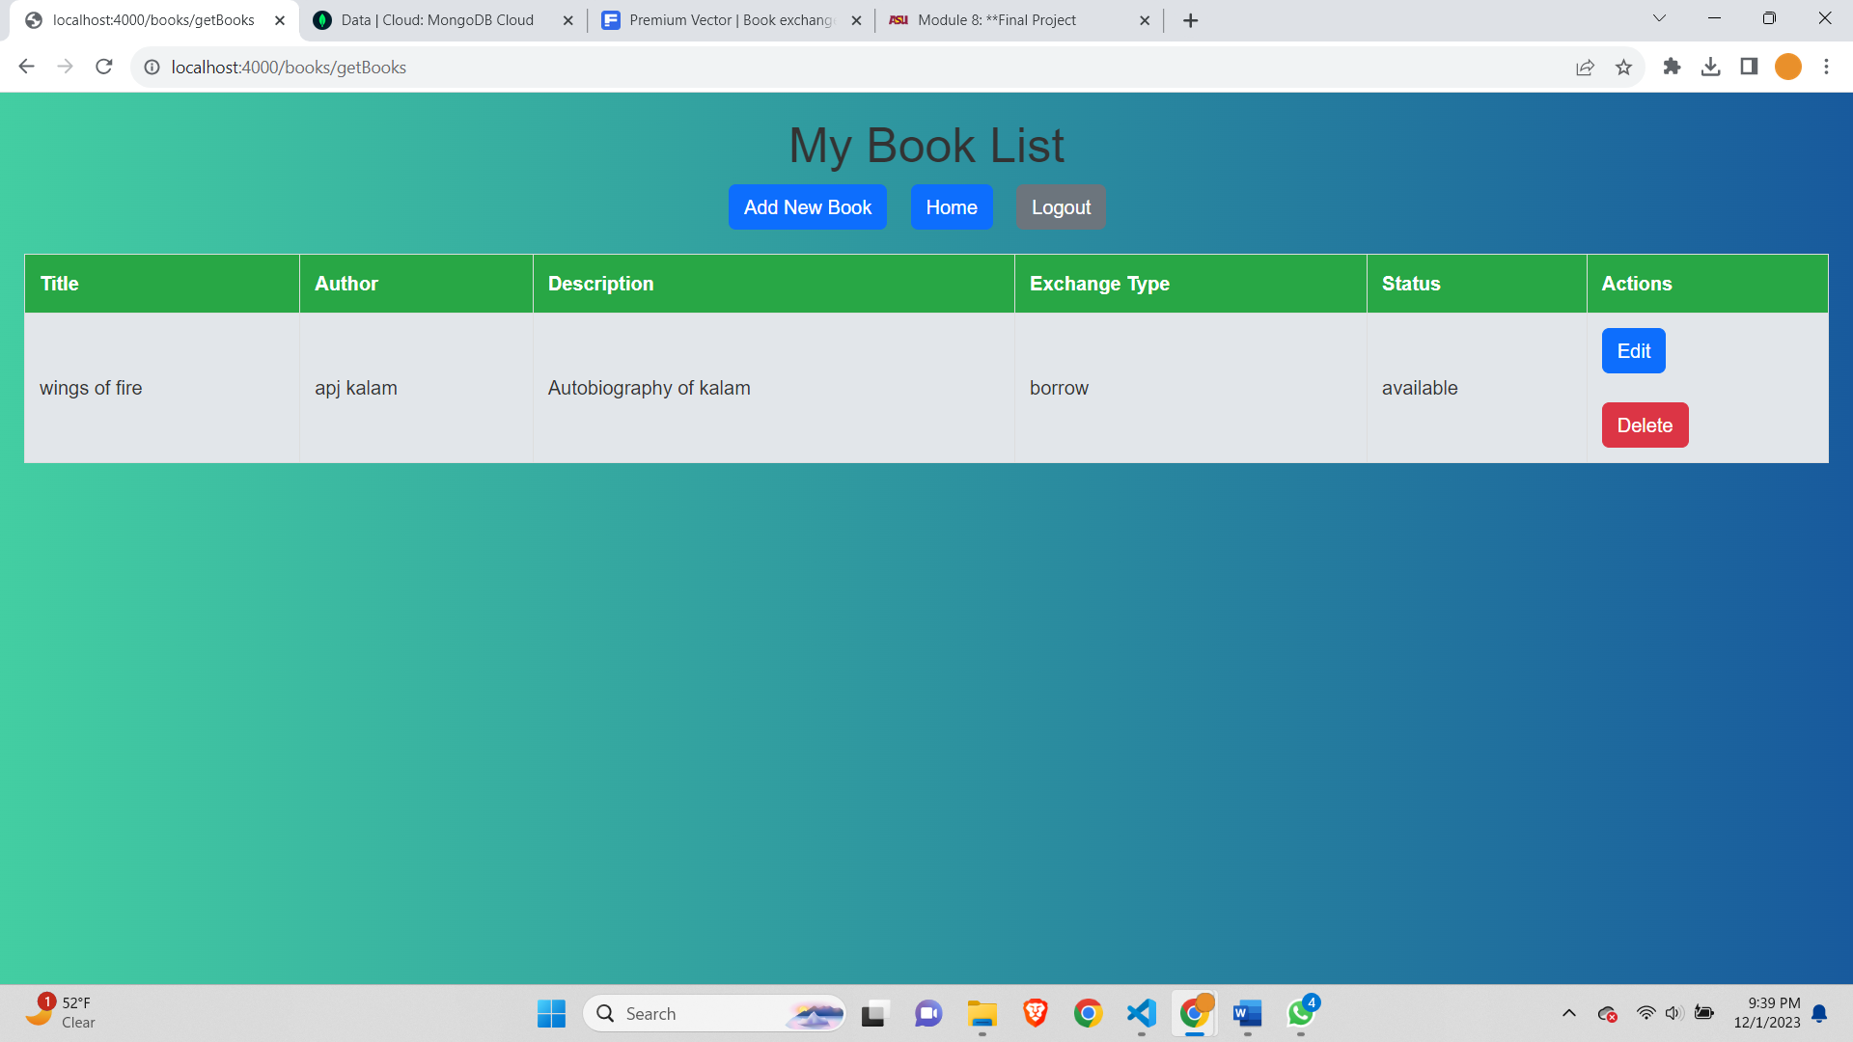

On clicking logout-

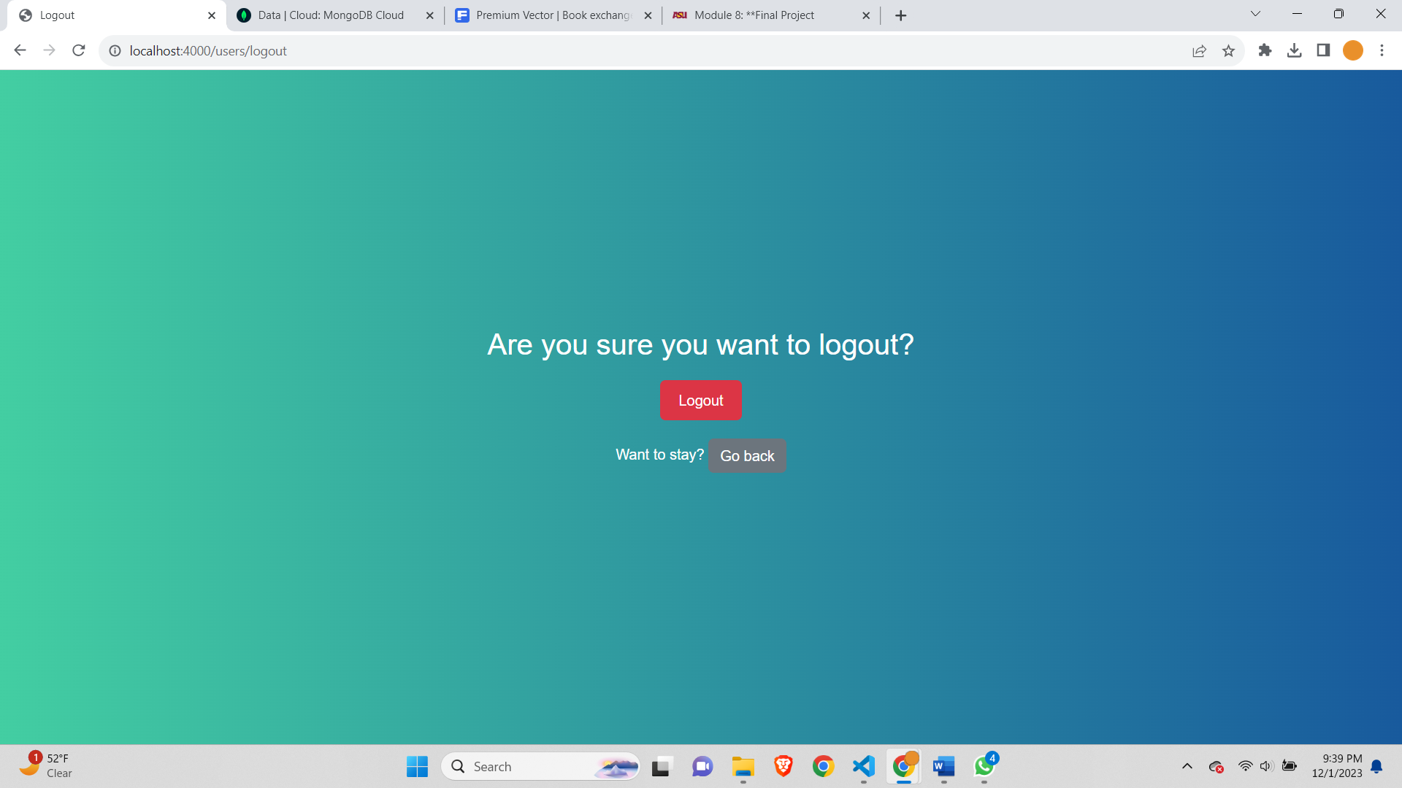

Second User registration-

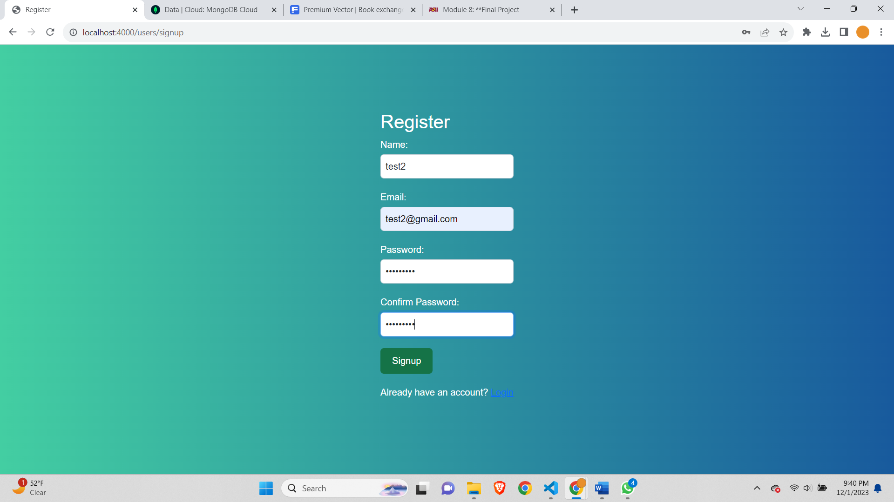

Add Book-

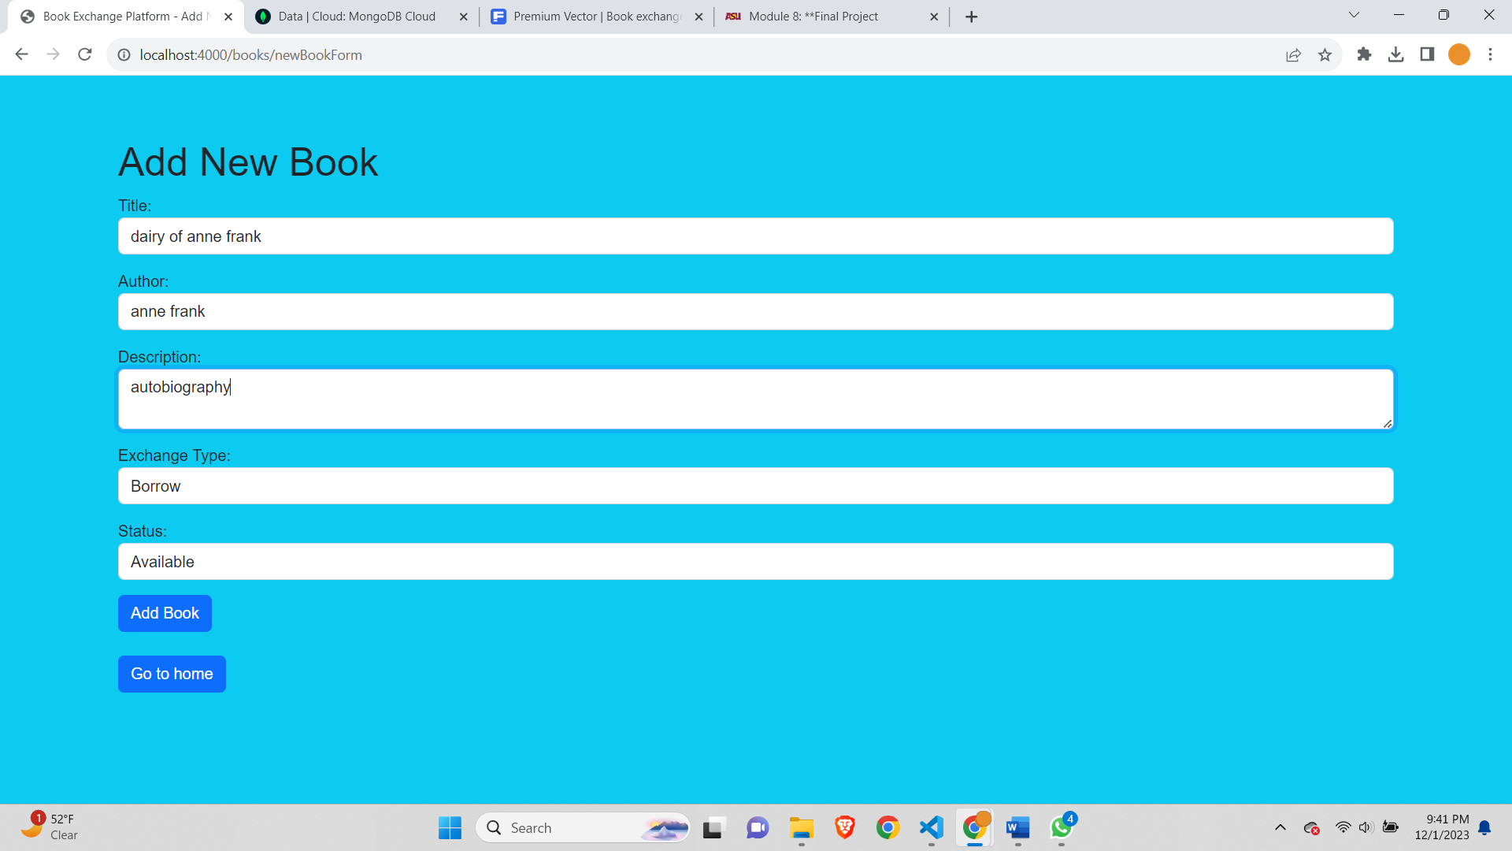

After adding book in test2-

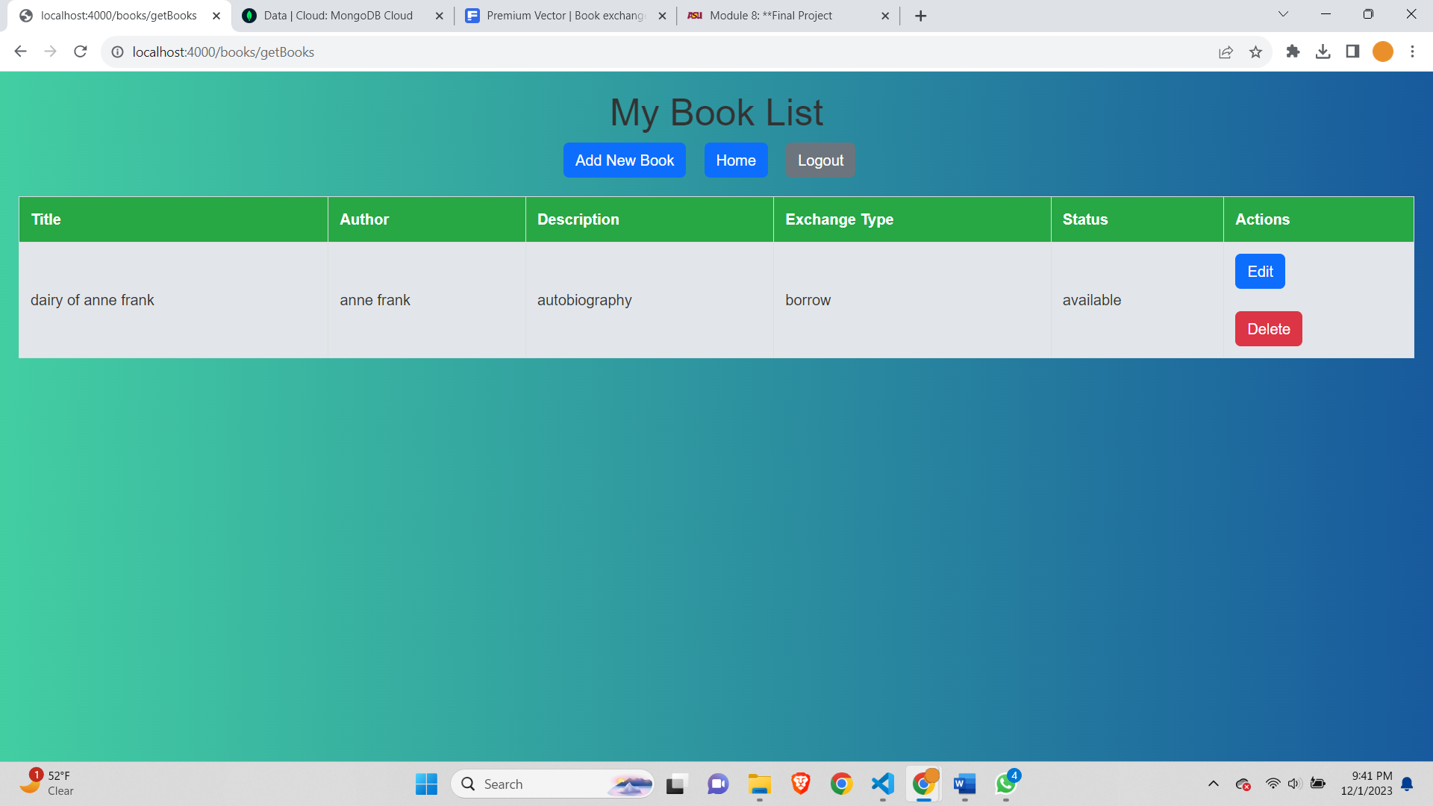

Requesting for book of different user (test1) we are test2 in this case-

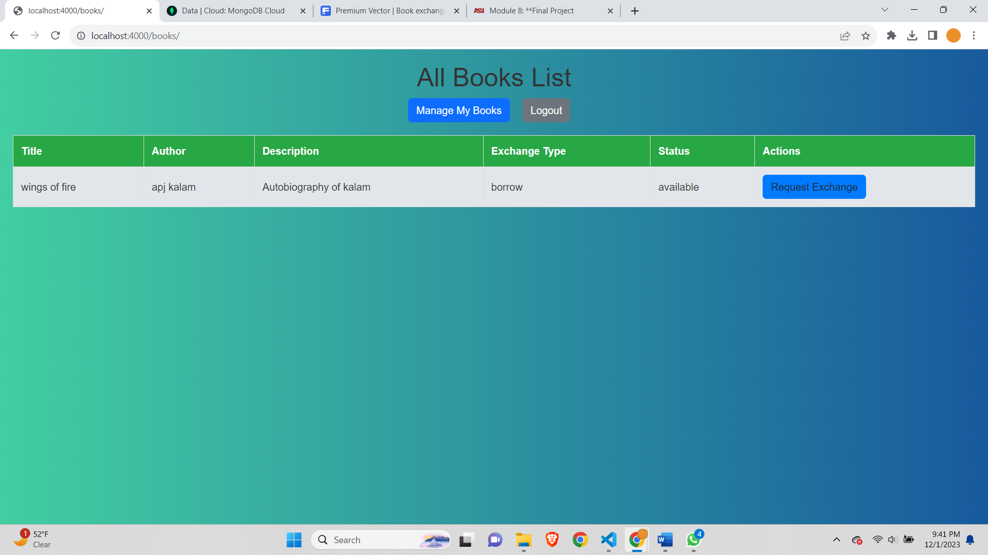

After Succesfully requesting-

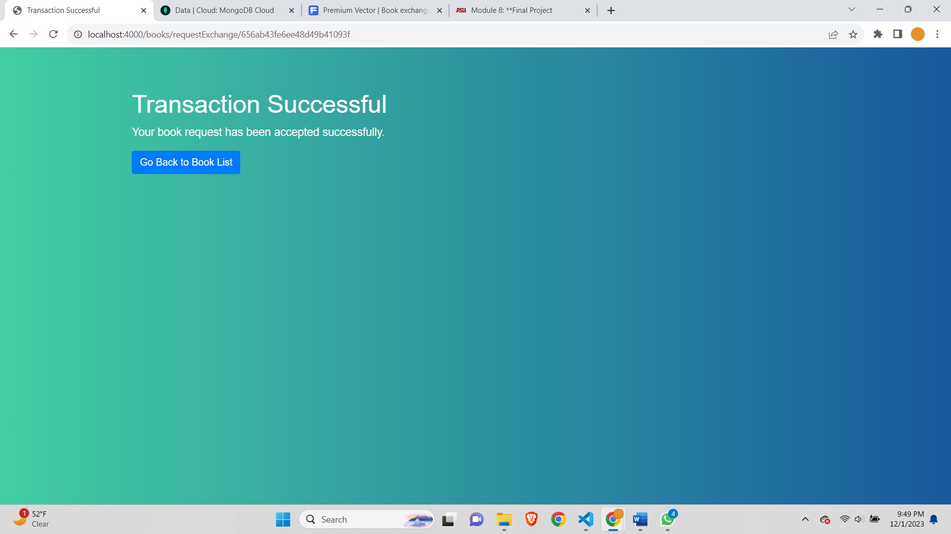

Accept the transaction from again first user (test1)-

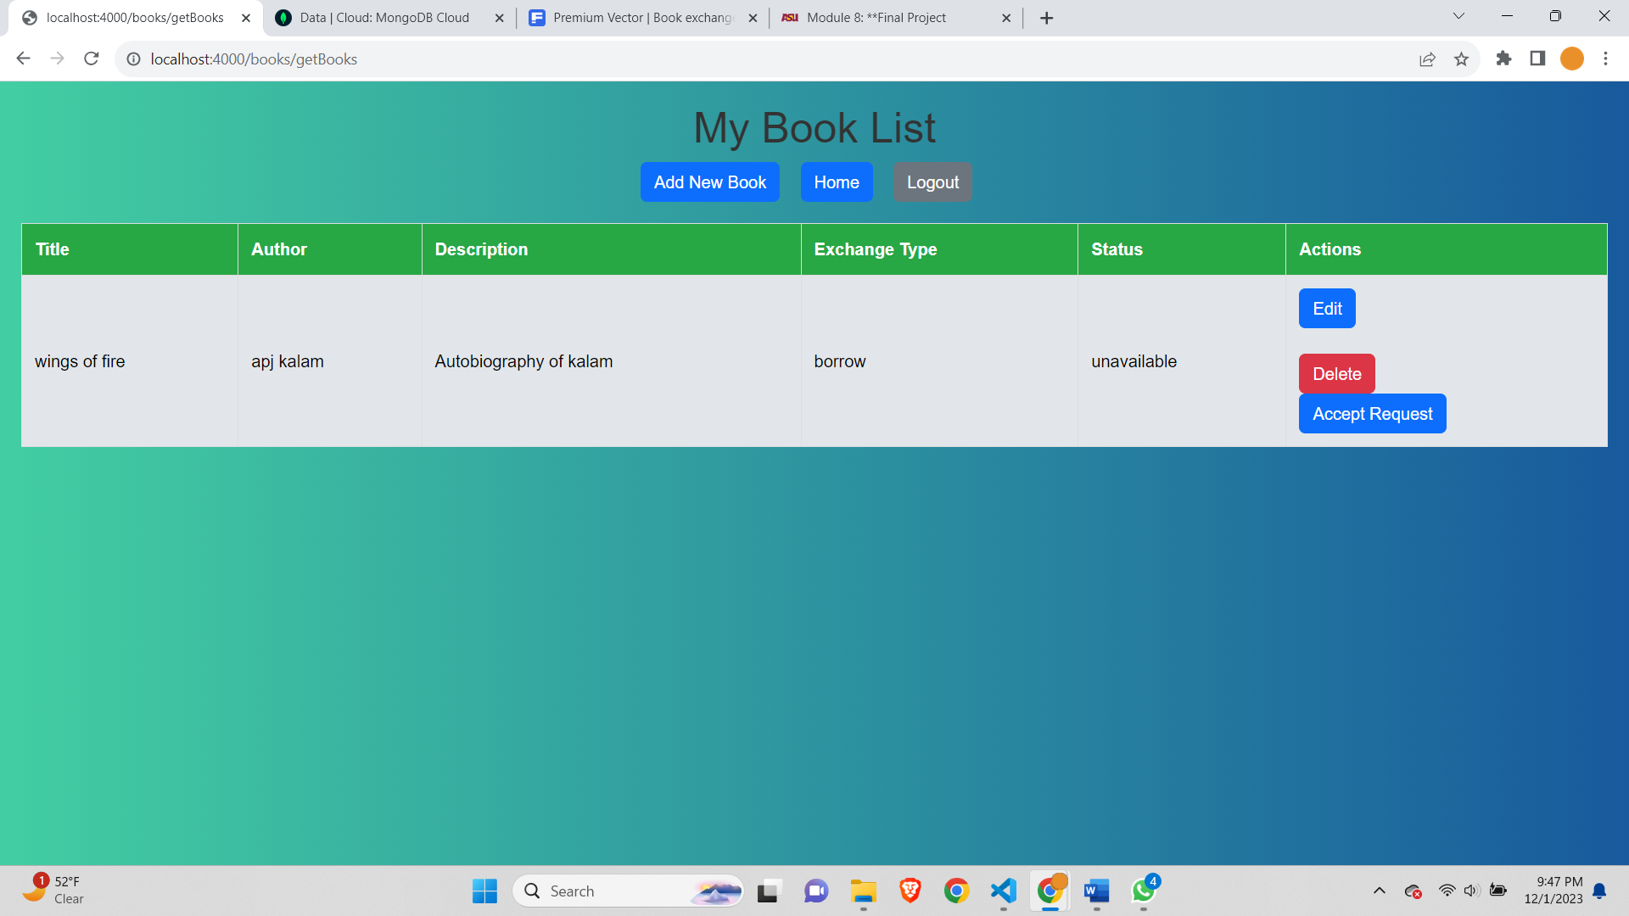

After accepting the test cases-

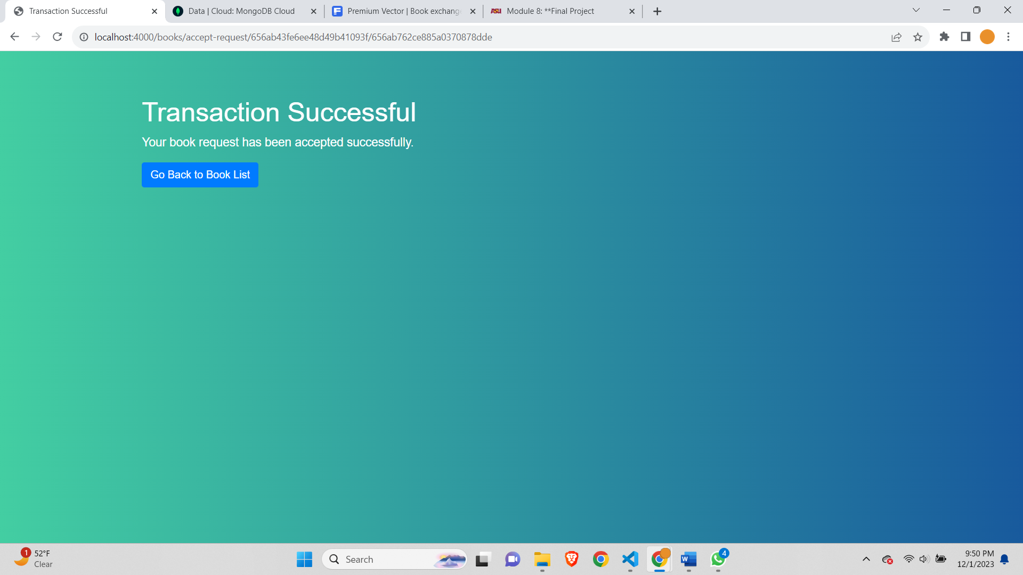

After requesting for book the book becomes unavailable and the button to request disappears-

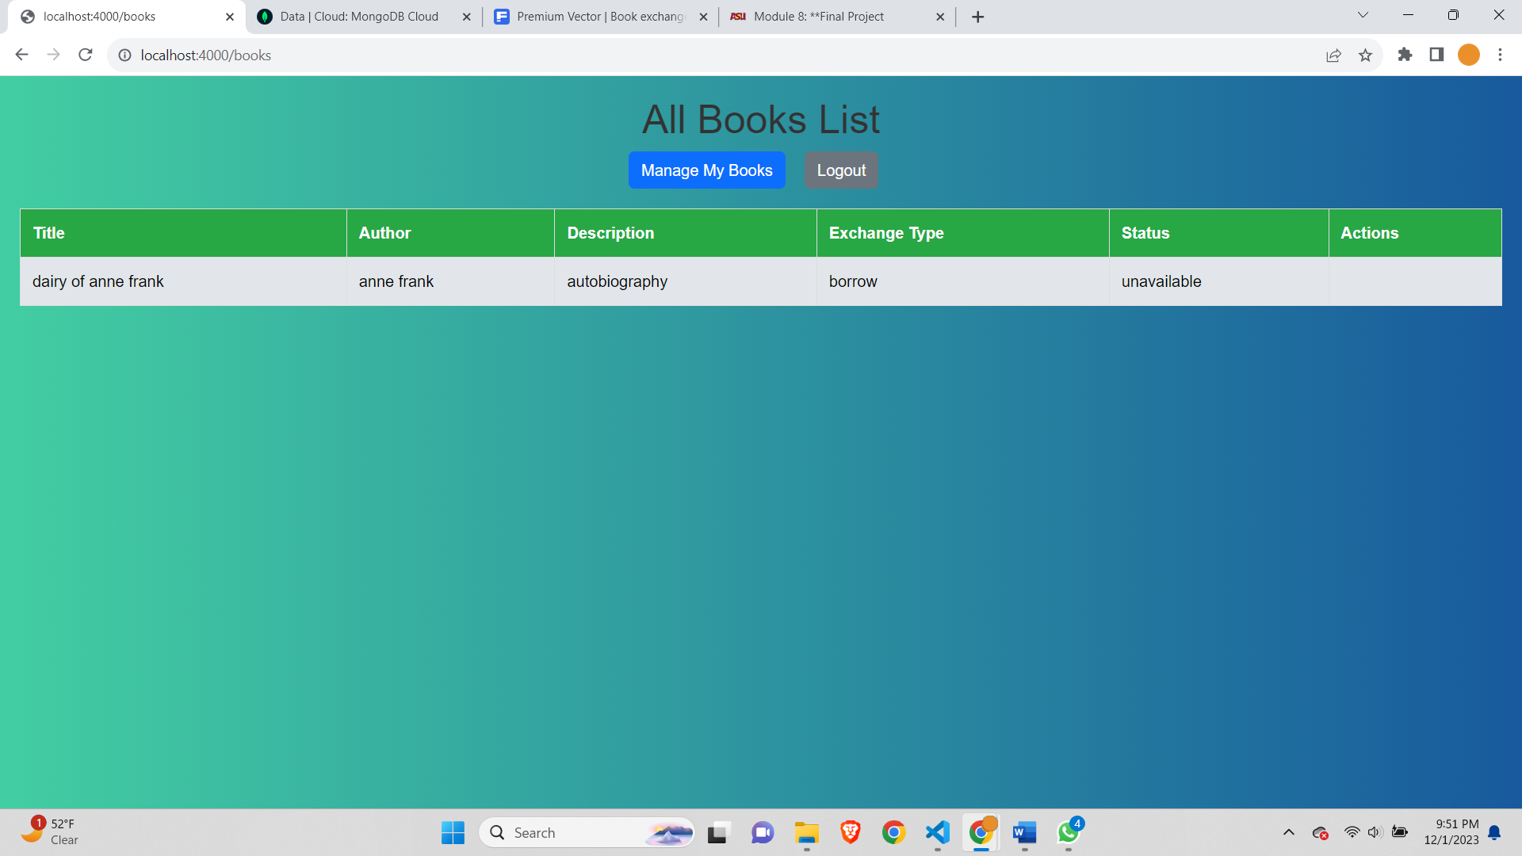

About page-

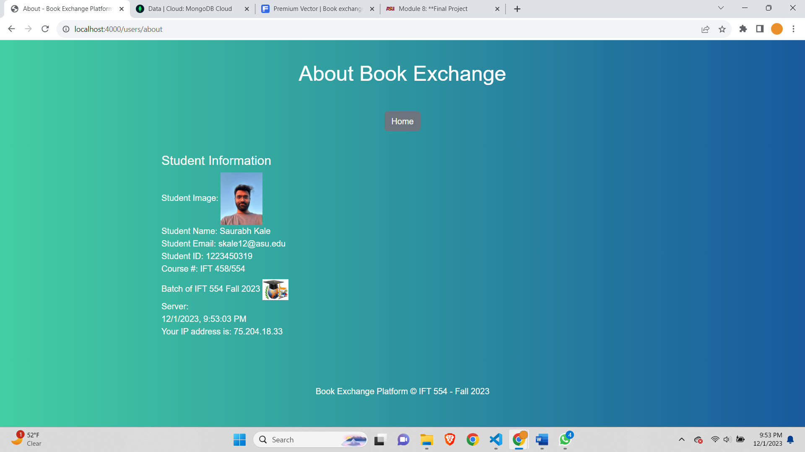

Testing

Get Books will get books for this user only-

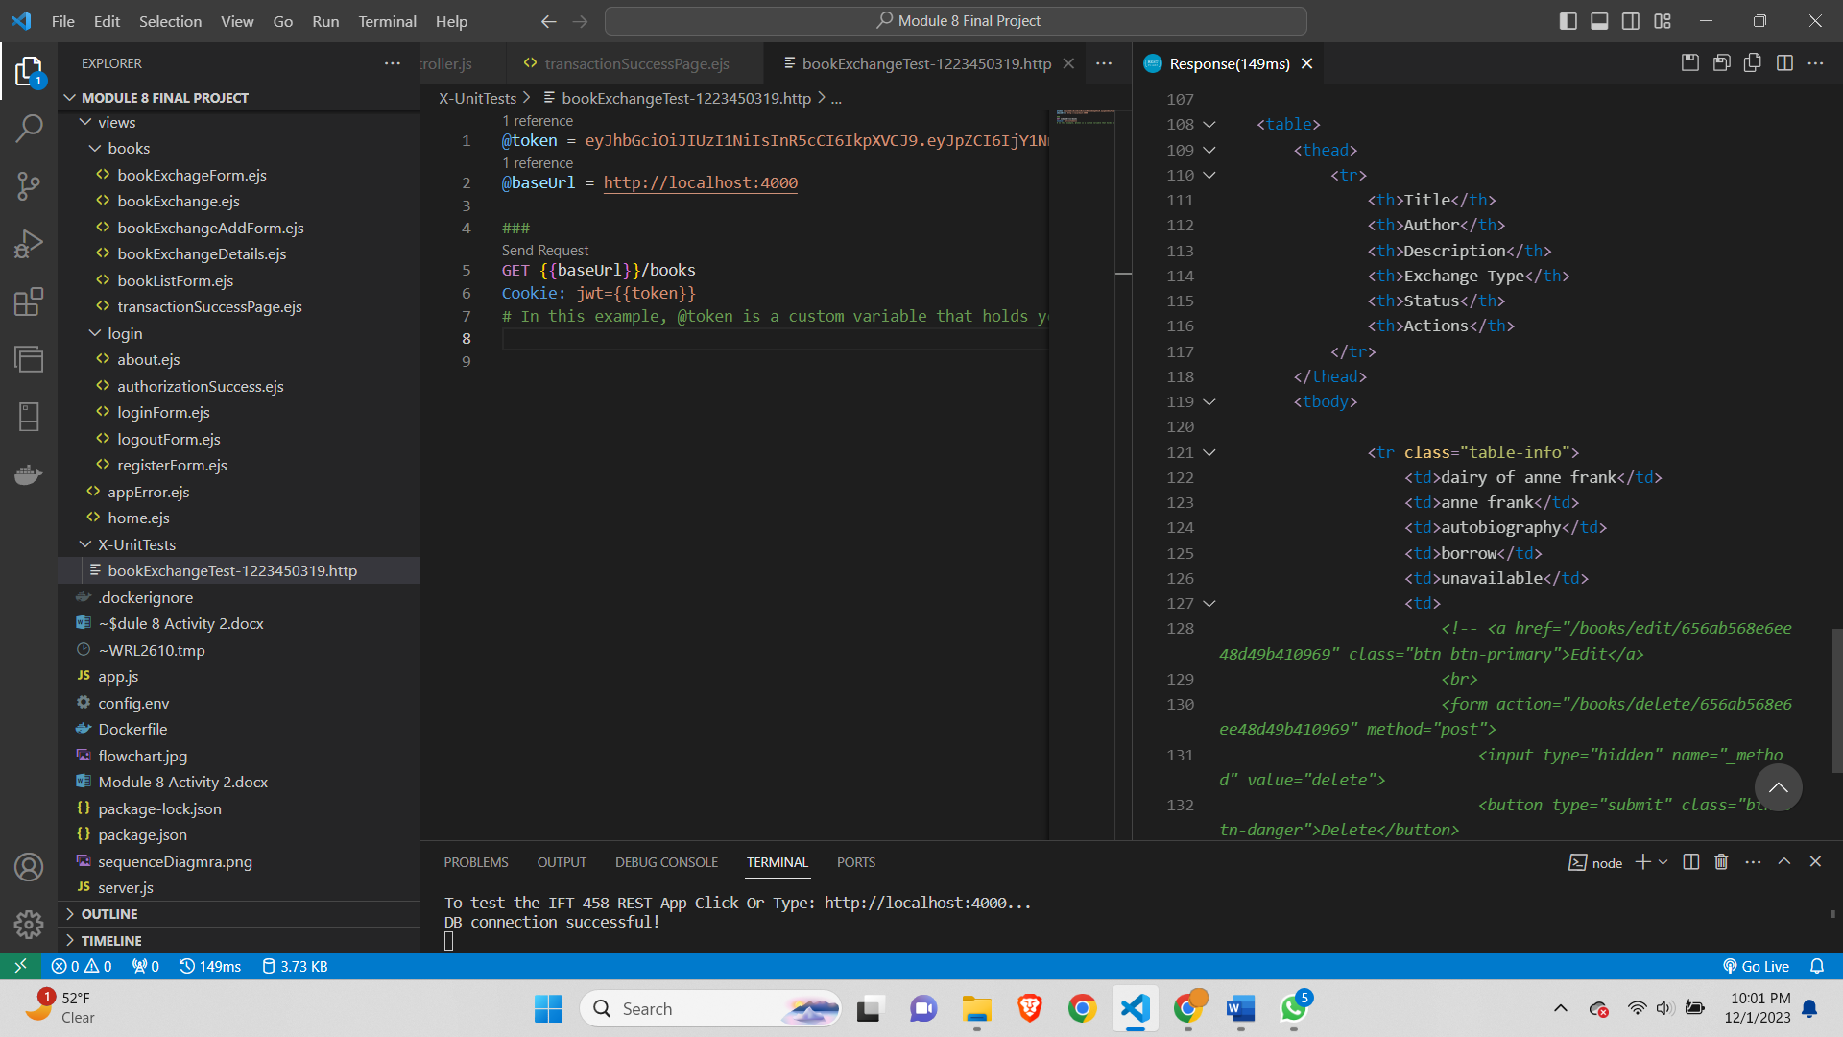

Create Books-

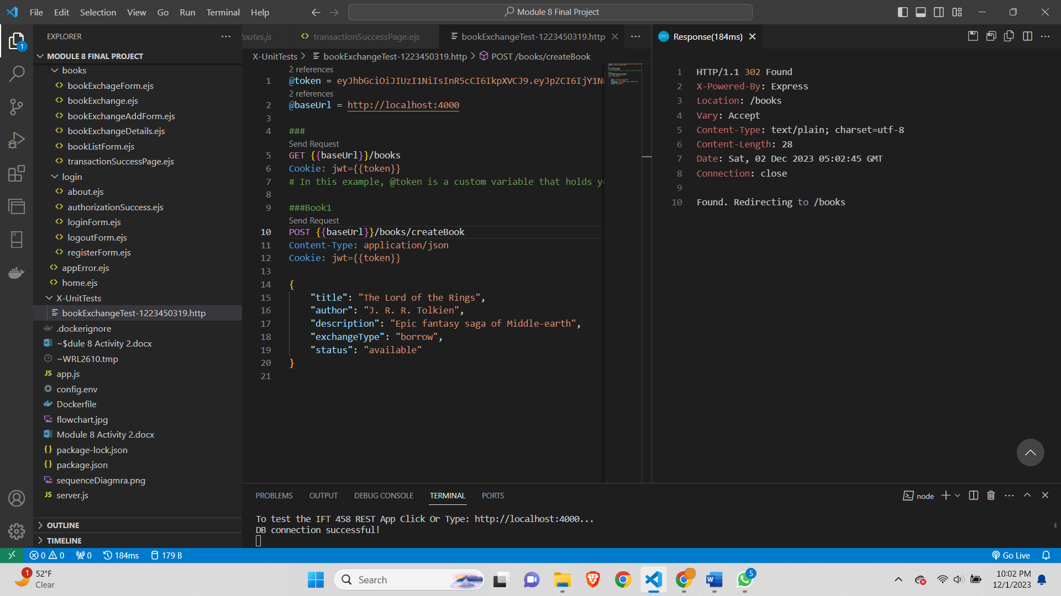

Book Added-

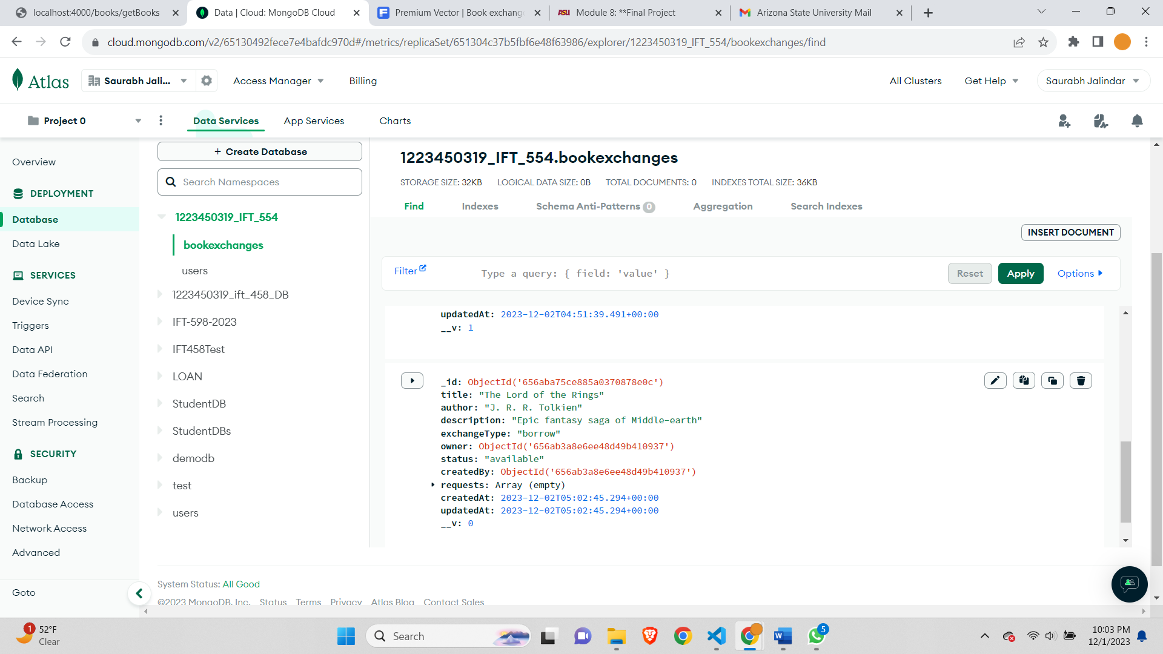

Get specific Book-

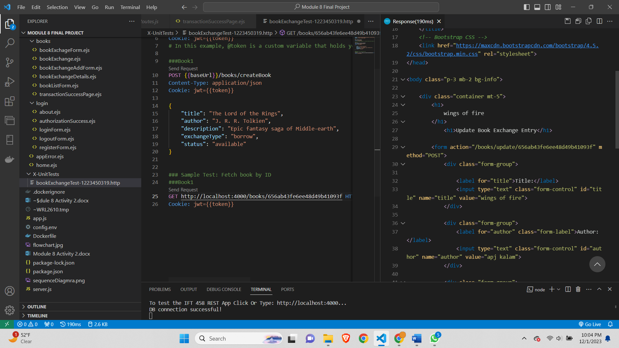

Update The Book-

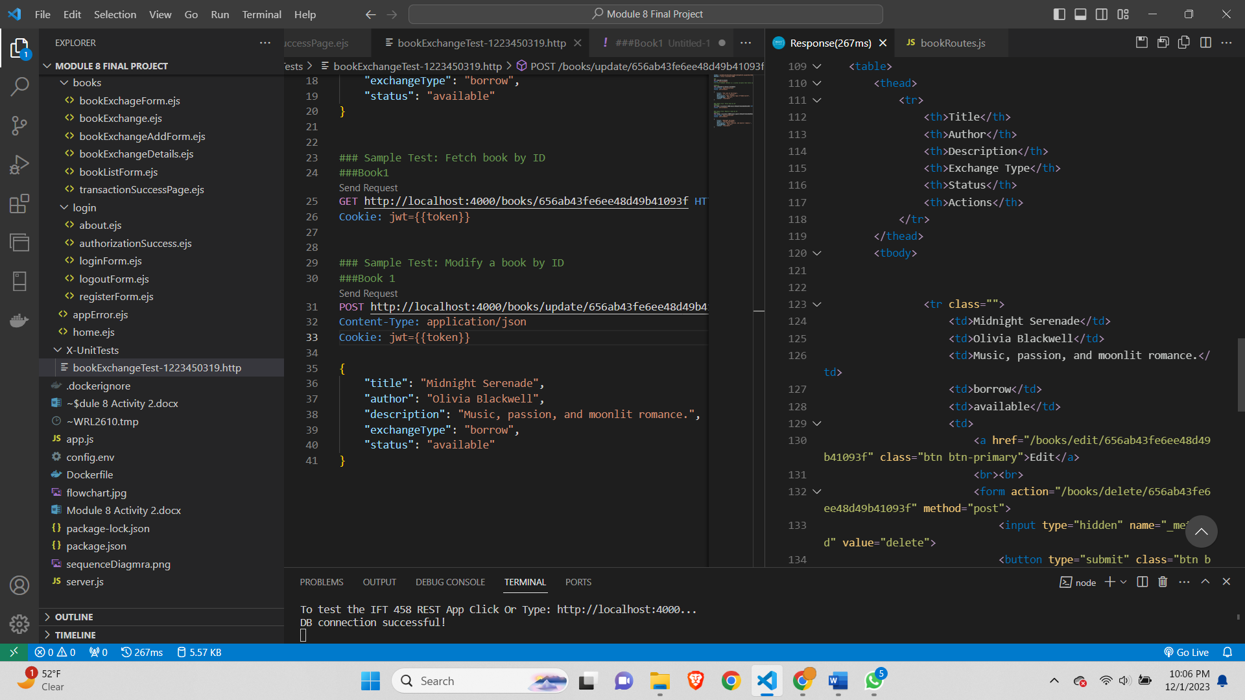

Update using PUT-

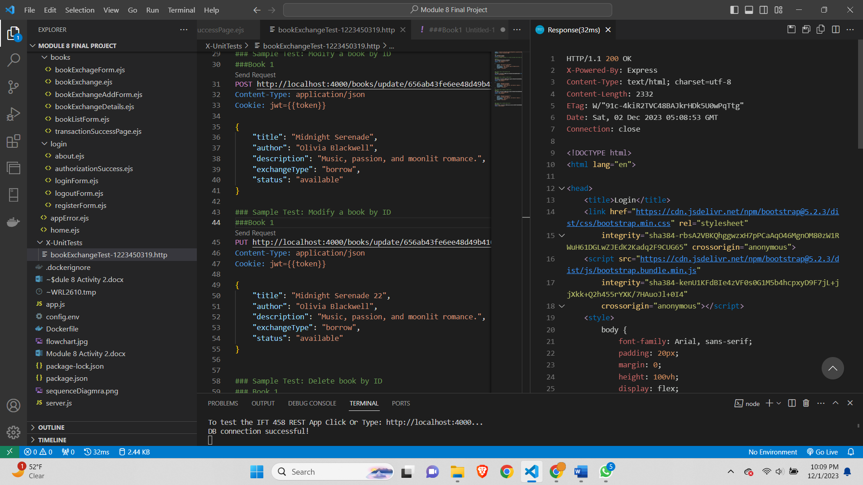

Delete using delete method-

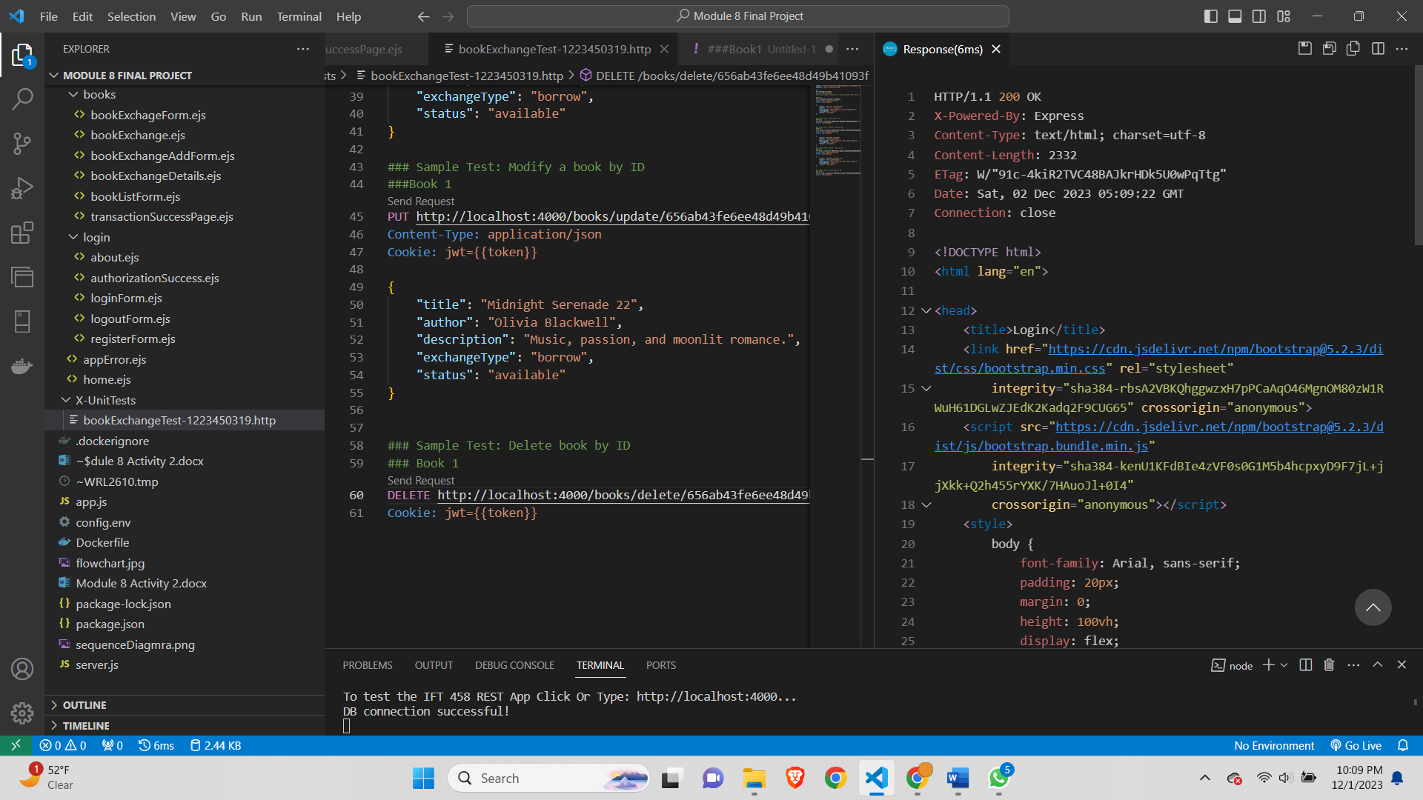

Implementation

**Challenges faced-**

* At some points I was not able to see the UI changes. For which the workaround was to give hard refresh which is ctrl + shift + r.
* Some typo mistakes were made and which had to be debugged using the console.log and sometimes the debugger terminal.
* Sitting at one point and trying to debug some errors for longer time didn’t help few times. After taking a break and coming back to the code helped me fix it within mins as I was fresh and looking from different angle to the code.
* Doing the accept transaction and request transaction was one of the difficult part as it took some time thinking where and what we have to do.
* Comprehensive testing of various scenarios, including user authentication, book transactions, and error cases.

**Key Functionalities-**

1. **User Authentication:**
   * Allowing users to sign up with a name, email, and password.
   * Encrypting and securely storing user passwords using bcrypt.
   * Enforcing password length requirements.
   * Implementing a login mechanism that checks user credentials against stored data.
   * Generating and sending JSON Web Tokens (JWT) upon successful authentication.
2. **User Authorization:**
   * Assigning roles to users (client, staff, student, admin).
   * Protecting routes by implementing middleware for authentication and authorization checks.
   * Granting access based on user roles.
3. **Book Management:**
   * Allowing authenticated users to add new books to the system.
   * Defining a data model for books with attributes such as title, author, description, and exchange type.
   * Setting default values for book status and ownership.
   * Handling CRUD operations for books (Create, Read, Update, Delete).
   * Displaying a list of books owned by the current user and books available for exchange.
4. **Book Requests:**
   * Enabling users to request books from other users.
   * Managing a requests array within each book, including user information and request status.
   * Preventing users from requesting the same book multiple times.
   * Changing the status of a book to 'pending' when a request is made.
5. **Book Transactions:**
   * Allowing users to accept book requests, updating the request status to 'accepted.'
   * Changing the owner of the book to the user who accepted the request.
   * Displaying a transaction success page after a successful book request or acceptance.
6. **User Interface (UI):**
   * Rendering views using the EJS templating engine.
   * Providing a user-friendly interface for actions such as adding books, viewing book details, and managing requests.
   * Displaying relevant information based on user roles and actions.
7. **Error Handling:**
   * Implementing error handling for various scenarios, such as incorrect login credentials, duplicate book requests, and database errors.
   * Rendering error pages with meaningful messages to users.
8. **Security Measures:**
   * Incorporating JWT for secure user authentication.
   * Using bcrypt for password hashing to enhance security.
   * Implementing middleware for protecting routes and checking user roles.
9. **Logout:**
   * Providing users with the ability to log out of their accounts.
   * Clearing the JWT cookie upon logout.

Learning Outcomes

* In module 5 we learned the JWT token authorization, MongoDB, MVC architecture and using the config.env file which I could use all of these things in my project.
* In Module 6 we learned JWT token in depth and got good practice of using it.
* In Module 7 we understood the flow diagrams and implemented it in the project. The sequence Diagram, flowcharts,etc are learned and implemented in the project.
* Learn how to interact with a MongoDB database using Mongoose, an ODM (Object Data Modeling) library.
* Understand schema creation, model definition, and CRUD operations in MongoDB.
* Gain proficiency in using Node.js for server-side JavaScript development.
* Understand the fundamentals of Express.js, a popular web application framework for Node.js.

Constructive Feedback

The course takes good practice of code and step by step implementation of the topic. Although the professor tries to get doubts from students and the graders are too helpful. If we had to give a suggestion then my suggestion would be to start a different online class for students those who want to learn the things. As few of the students are scared to ask doubt. In online class in mid week professor or the grader can explain step by step what is the assignment and what things are needed to be done. As by the mid week students might start the assignment and can have doubts to ask.

References

Image was taken from-

*Book exchange landing page template or bookcrossing vector illustration banner education and knowledge concept diverse hands holding books swap literature event library day culture festival Premium Vector*. (2022, November 8). Freepik. https://www.freepik.com/premium-vector/book-exchange-landing-page-template-bookcrossing-vector-illustration-banner-education-knowledge-concept-diverse-hands-holding-books-swap-literature-event-library-day-culture-festival_34126356.htm

*MongoDB documentation*. MongoDB Documentation. <https://www.mongodb.com/docs/>

*Documentation | Node.js*. https://nodejs.org/en/docs